# **Book Review Portal**

## **Members Of The Project:**

* 1702472 Ensar Buğrahan Erdağ
* 1505453 Tolga Arslan

## **The Aim:**

Book Review Portal consists of one database which contains all the necessary information about a review such as the name of the books and authors, categories, review text, adding date and other information about the books. The aim of this project is to allow the users to add new reviews and share their thoughts about the book they have read. This project is developed using ASP.NET MVC framework, front-end frameworks such as Bootstrap and Jquery and SQL used for back-end database during the development.

## **Use-Case Diagram:**

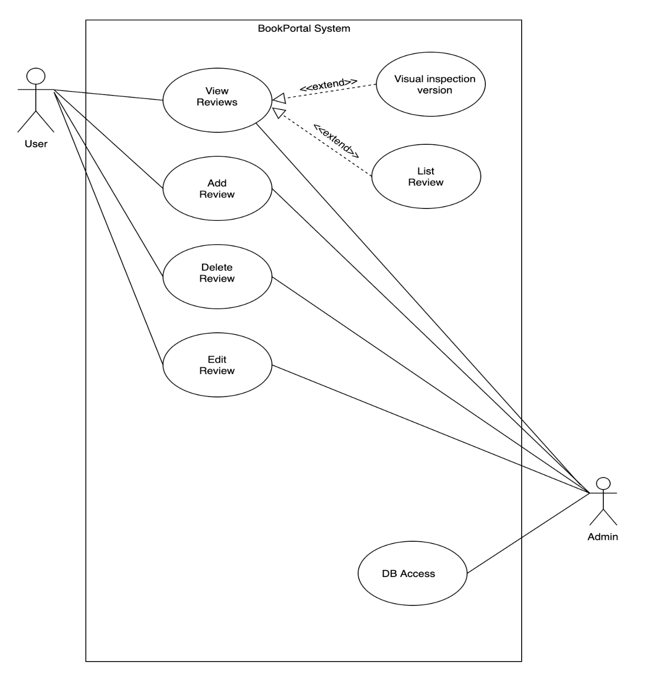

## **The Flow of The Project:**



Figure 1 Home Page

Fig 1: This is the home page of our website. The user can browse through the pages by using the top-right buttons, can see the top 5 reviews, 5 most recent reviews and the 5 oldest reviews on the website by clicking on the “See More” buttons located on the header or can click on the images under the “Popular Categories” which represent categories and upon click, they navigate the user to pages where they can display reviews filtered by the corresponding category depends on which category the user have choosen.

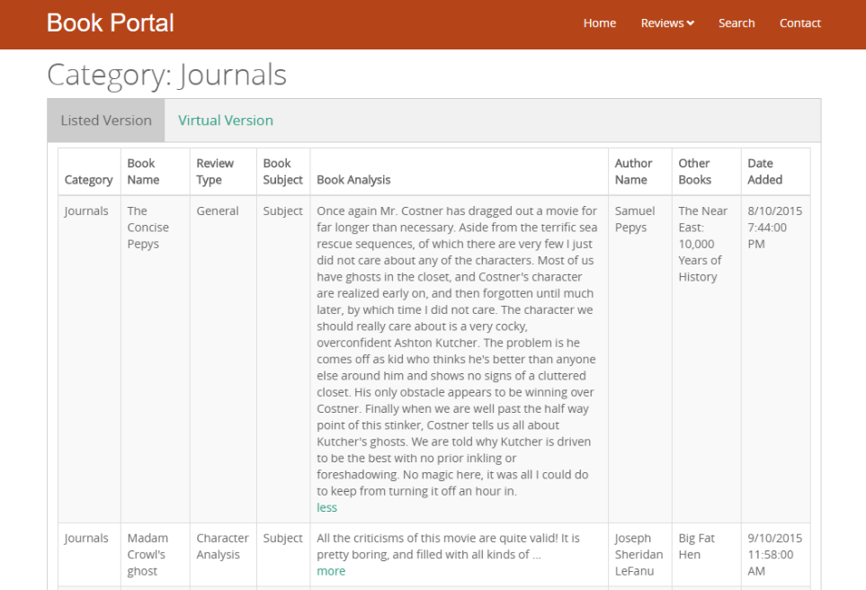

Figure 2 Category Filtered Pages-Listed Version

Fig 2: After clicking on any of the 6 images under “Popular Categories”, the user will be redirected to the pages where they can read their favorite category’s book reviews. Users can select the display method via this screen.They can review book reviews in list view or visual view.

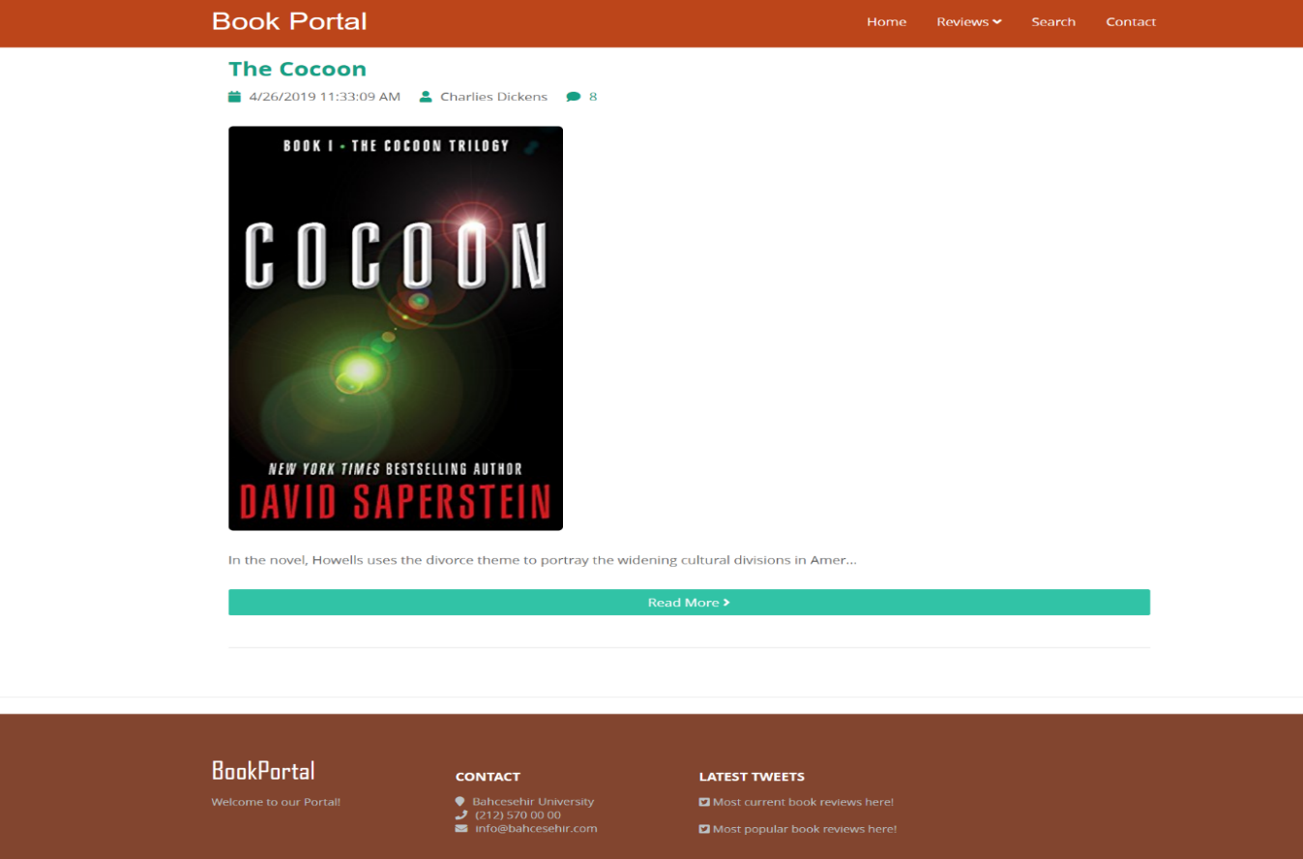

Figure 3 Category Filtered Pages-Visual Version

Fig 3: When the user clicks on the visual view, the user can view the visual reviews of the books of the selected category.

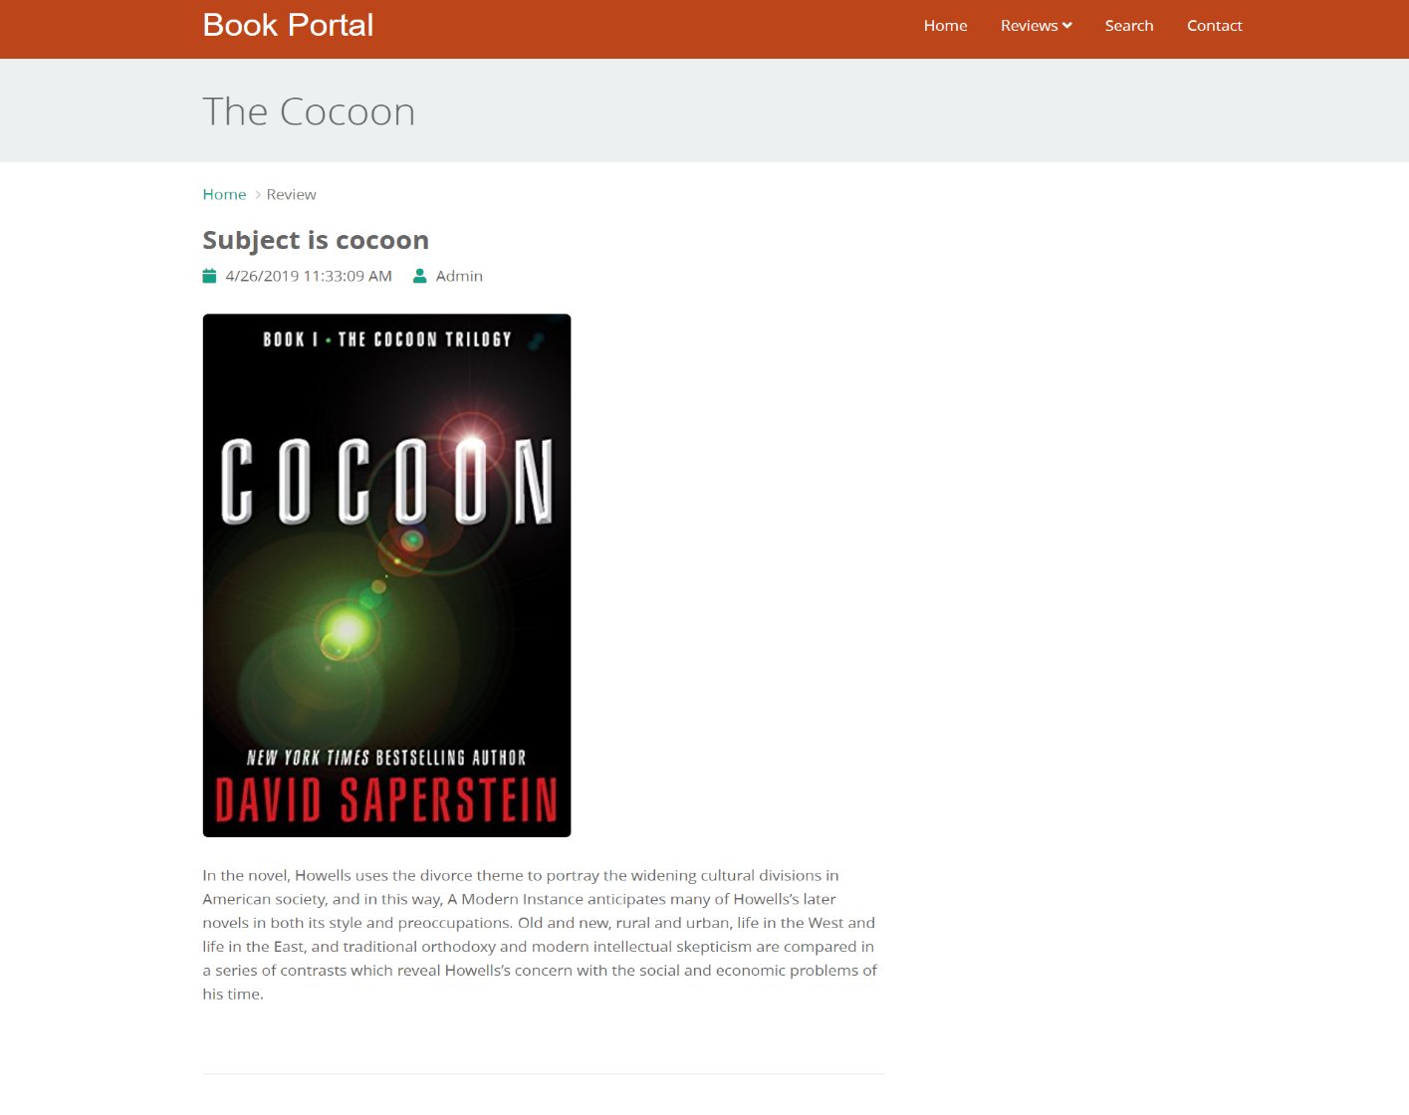

Figure 4 Detailed Review Pages

Fig 4: The user can access the detailed review content by pressing the "Read More" key. Users can view the title of the book, the subject of the book, the upload date of the review, the person who added the review, the picture of the book and the text of the book review in the detailed review page.

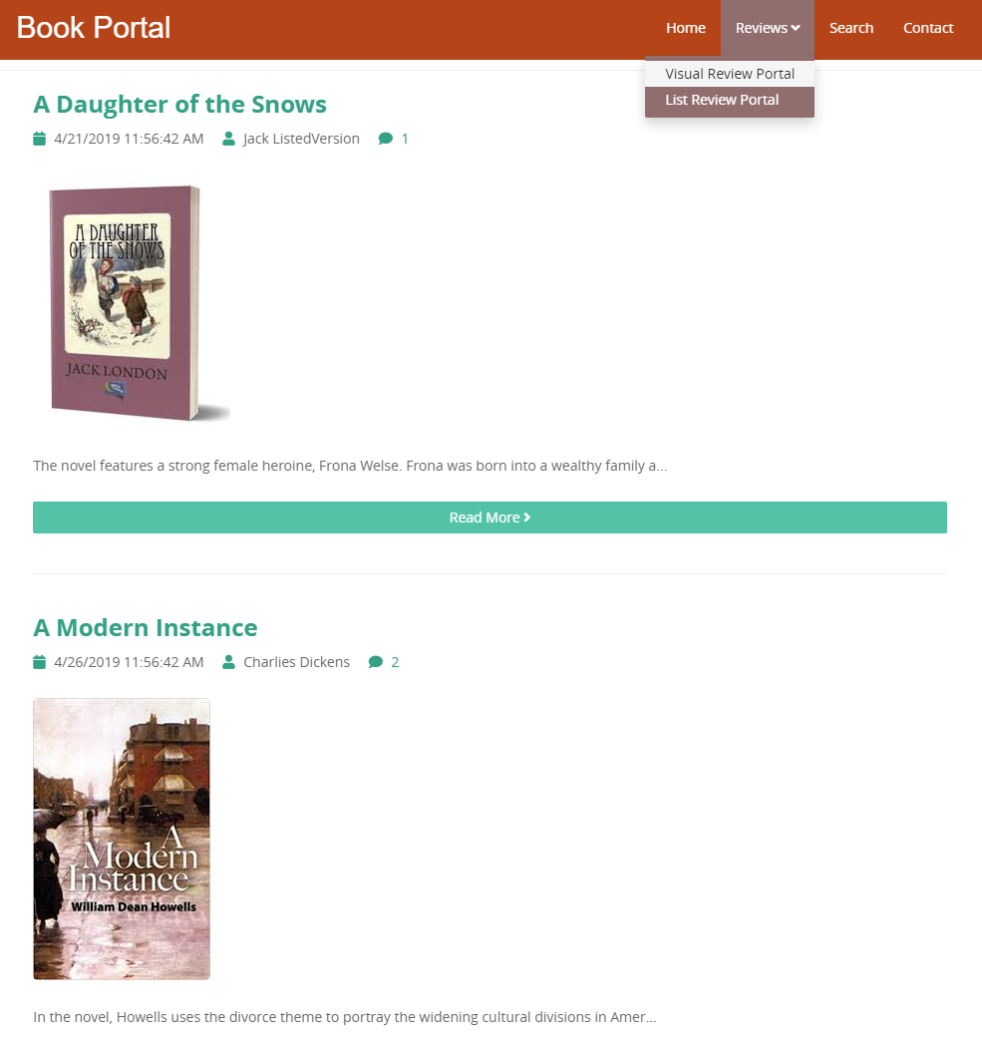

Figure 5 Reviews Page - Virtual Display

Fig 5: If the user choose the Virtual display option from anywhere the option available in the website, s/he will come across with these styled pages.

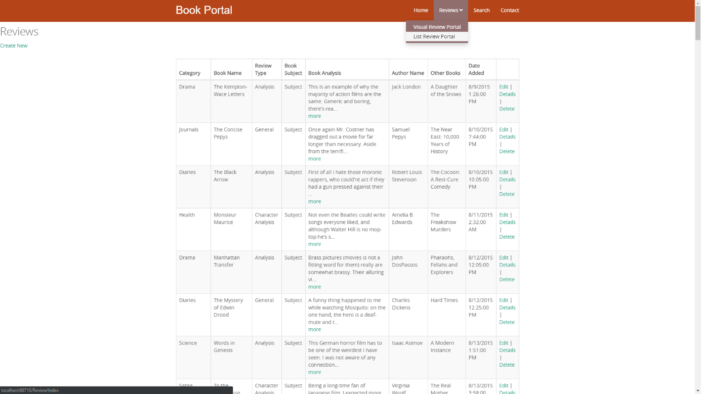

Figure 6 Reviews Page - List Display

Fig 6: In Reviews page, the admin can display all the data stored in the database and edit, remove or add a new review.

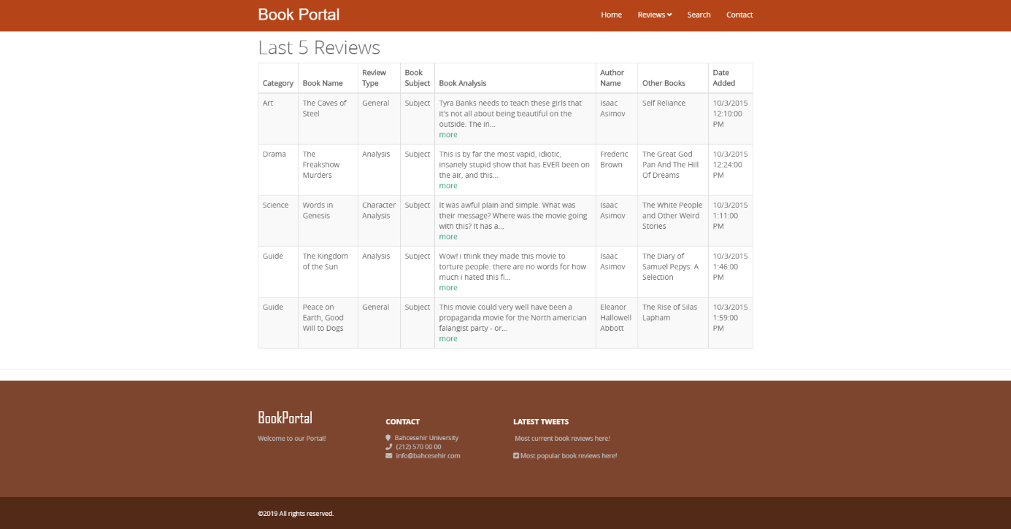

Figure 7 Last 5 Reviews Page - List Display

Fig 7: One of the pages when the user uses the “See List Version” button on the carousel located on the header of the homepage.

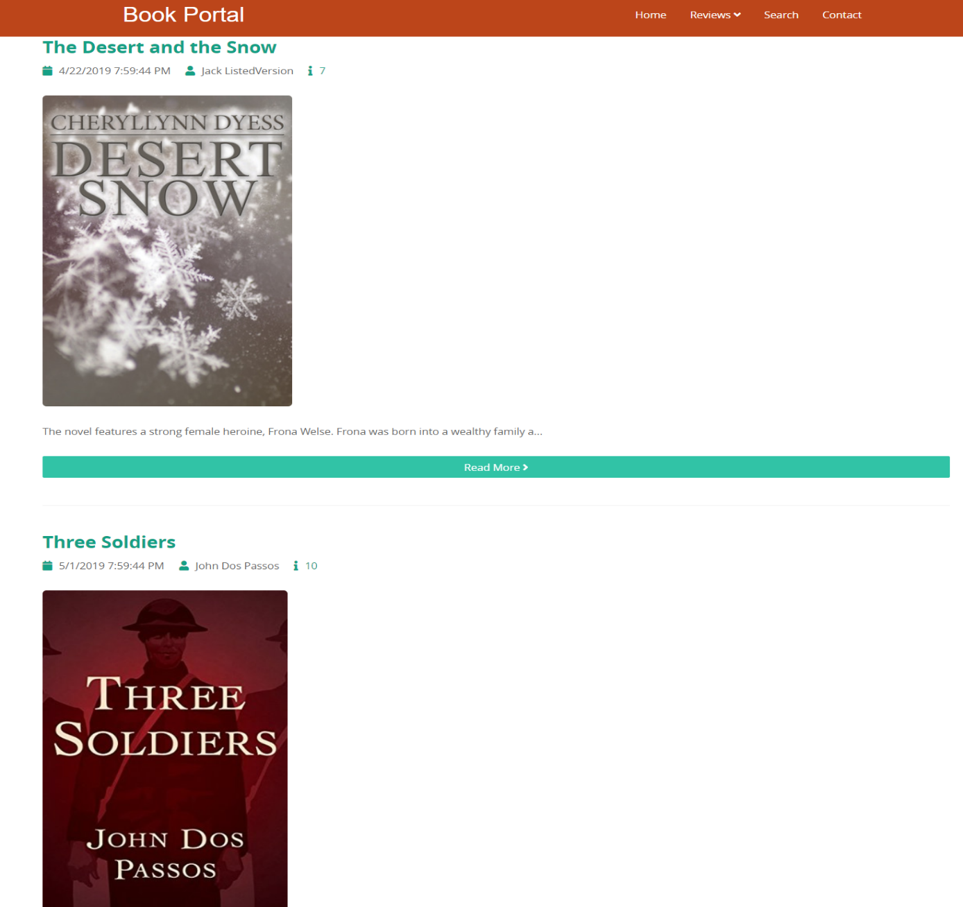

Figure 8 Last 5 Reviews Page - Vİisual Display

Fig 8: One of the pages when the user uses the “See Visual Version” button on the carousel located on the header of the homepage.

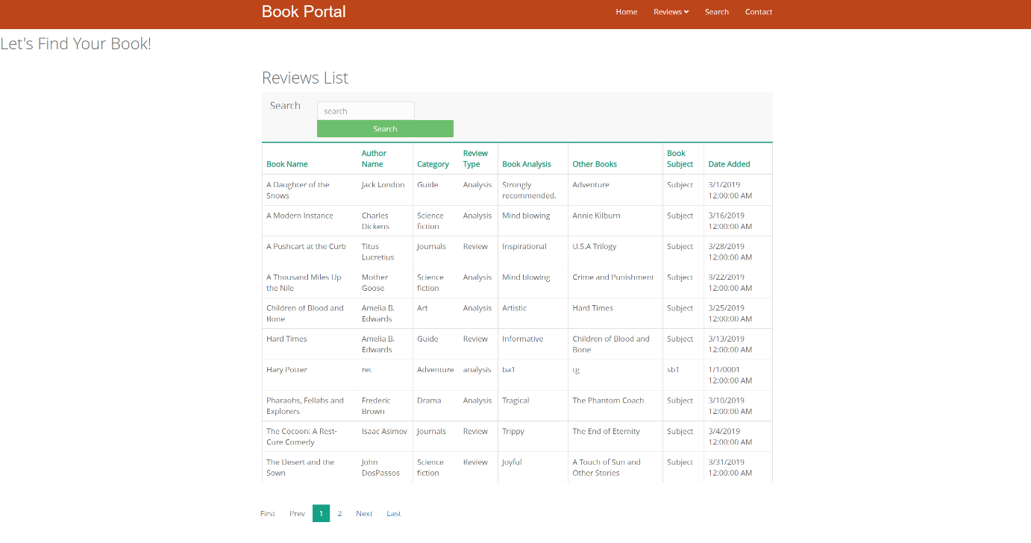Figure 9 Search Page

Fig 9: In Search Page, the user can find a book that s/he have on his/her mind by writing the book’s any information on the search text box and clicking on the search button. The user can also order the rows by clicking any of the columns once for A-Z and twice for Z-A.

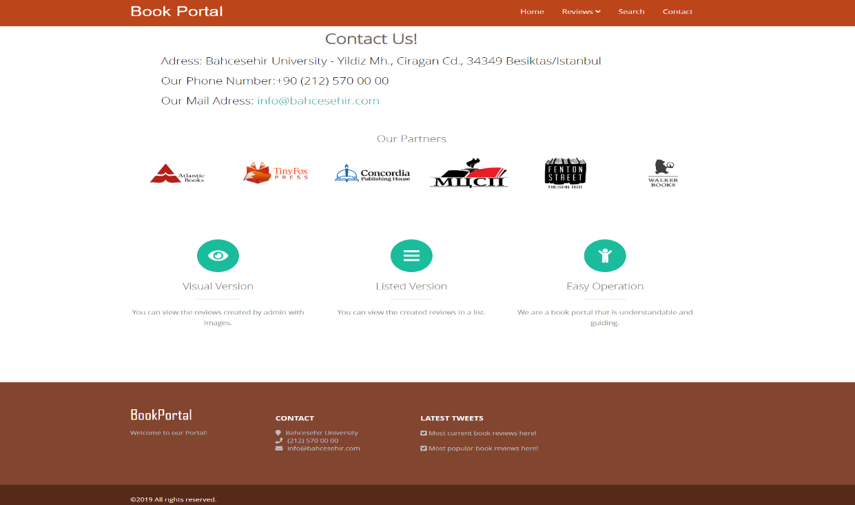

Figure 10 Contact Page

Fig 10: The user can contact the developers by choosing one of the communication addresses displayed in this page.

## **References**

* <https://docs.microsoft.com/en-us/aspnet/mvc/overview/getting-started/introduction/getting-started>
* <https://github.com/mdobie/WebGridPagerReplacement/blob/master/WebGridExtensions.cs>